***EQUIFAX***

CMS Fusion

**DATA PROCESSING**

**DOCUMENTATION**

Table of Contents

1. Data Processing Tab 4

Data Processing Input 5

Data Processing Output 5

View of Data Processing Tab Status 5

1.1 Do Not Solicit 6

1.1.1 Process Name 7

1.1.2 Select input 7

1.1.3 Name and Output Table 7

1.2 Random Nth 8

1.2.1 Process Name 9

1.2.2 Select input 9

1.2.3 Name and Output Table 9

1.2.4 Number to Output 9

1.2.5 Record to Process 9

1.3 Full File Fixed 10

1.3.1 Process Name 11

1.3.2 Datapump Series 11

1.3.3 Credit Input 11

1.3.4 Select input 11

1.3.5 Config File Location 11

1.3.6 Record Types 11

1.4 Filter 12

1.4.1 Process Name 13

1.4.2 Select input 13

1.4.3 Name and Output Table 13

1.4.4 Perform Cuts 13

1.4.5 Group Name and Condition 13

1.5 Match /Join 15

1.5.1 Process Name 16

1.5.2 Select input 16

1.5.3 Match File Select input 16

1.5.4 Record Types 16

1.5.5 Name and Output Table 16

1.5.6 Match Join Stats 19

1.6 Custom Data Setup 20

1.7 Rolling Suppression 21

1.7.1 Process Name 22

1.7.2 Select a Suppression Option 22

1.7.3 Name the Output Table 22

1.7.4 Select input 22

1.7.5 Record to Process 22

1.7.6 Apply Date Parameters 22

1.8 MLA Standalone 23

1.8.1 Process Name 24

1.8.2 DataPump Series 24

1.8.3 Select input 24

1.8.4 Output Table 24

**Revision History**

| **Revision** | **Author** | **Date** | **Status and Description** |
| --- | --- | --- | --- |
|  |  |  |  |
|  |  |  |  |
|  |  |  |  |

**Updates**

|  |  |  |  |  |
| --- | --- | --- | --- | --- |
| **Date** | **Story** | **Requirement** | **Section** | **Modified by** |
| 13/03/2018 | Sprint60(CF2-3417) | Match Join - Stats update test - POC | 1.5.6 Match Join Stat | Varnika Priydarshini |
|  |  |  |  |  |
|  |  |  |  |  |
|  |  |  |  |  |
|  |  |  |  |  |
|  |  |  |  |  |

# 1. Data Processing Tab

As the name indicates, the Data Processing tab is generally used to process the data received after an initial data selection, cleaning and refinement.

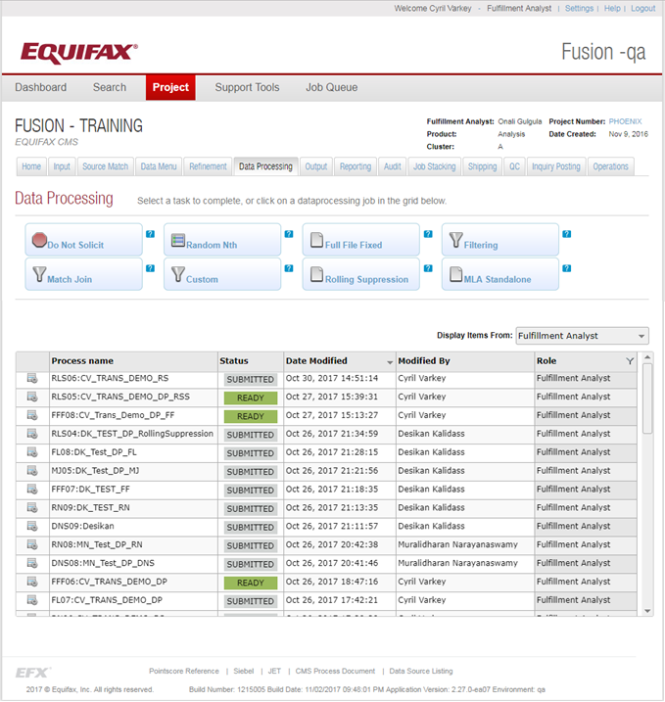

### Data Processing Input

The following are the data that is used for the data processing:

* Data received as the Input.
* Data received as resultant to Source Match processing.
* Data received as resultant to Data Menu processing.
* Data received as resultant to Refinement processing.
* Data received from the shipping file (Strictly in the case of *Rolling Suppression*).

The fulfilment analyst selects the Input process and the relevant data for the data processing. Once the Input is selected, the Job Id for the same is populated along with the process selection.

### Data Processing Output

Processed data as per the conditions and provided to the fusion’s Output tab for further processing.

### View of Data Processing Tab Status

The Data Processing tab enables the option to complete various tasks and it also displays a job grid, where all the Data Processing jobs are detailed.

Some of the fields of the grid are explained below.

* **Process Name**: All the Data Processing job names are displayed in this column.
* **Status**: Data Processing jobs has following valid statuses displayed in different colors:

1. *Submitted* (no color) – When the process is submitted successfully without any error, then this status is displayed.
2. *Ready (green)* – The process is saved and is ready to run.
3. *Warning (yellow)* – Currently not displayed.
4. *Error (red)* –When any issue occurs (like no module is selected), this status is displayed

* **Date Modified**: Date & time when the process is last modified in military format
* **Modified By:**  Name of the person that performed the last edit on the corresponding process.
* **Role:** The role of the user - Fulfillment Analyst/Programmer/QC

The Data Processing tasks available are listed as follows:

1. **Do Not Solicit**
2. **Random Nth**
3. **Full File Fixed**
4. **Filter**
5. **Match /Join**
6. **Custom Data Setup**
7. **Rolling Suppression**
8. **MLA Standalone**

## 1.1 Do Not Solicit

Each year American consumers receive several billion written offers of credit or insurance they did not request. In many cases, the senders have prescreened the recipients for creditworthiness and suitability using consumer credit records in the files of consumer reporting agencies.

The Fair Credit Reporting Act (FCRA) permits creditors and insurers to use CRA information as a basis for sending unsolicited firm offers of credit or insurance, also known as prescreened solicitations, to consumers who meet certain criteria, but only within limits specified in the act. The FCRA also provides a mechanism by which consumers can elect not to receive such solicitations by directing CRAs to exclude their names and addresses from lists provided by these agencies for sending prescreened solicitations. Consumers who choose to have their names removed from lists used for prescreened solicitations may well still receive offers of credit or insurance by mail or telephone, but such offers will not be based on the credit records maintained by the CRAs.

People are able to opt out of receiving any offers from U.S. national credit bureaus.

This is incorporated as part of Data Processing in Fusion, as per the below screenshots.

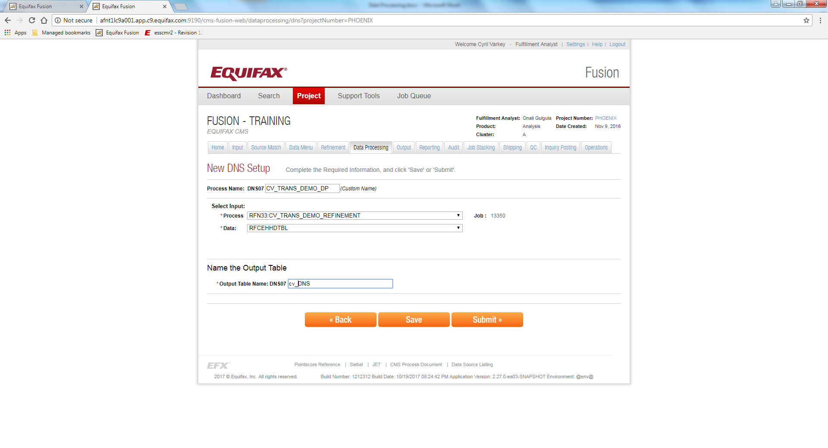

### ****1.1.1 Process Name****

This field is used to give a name for the Data Processing job. It is prefixed with an auto generated keyword called as **Process Identifier**, which is used to given the unique names process, so the user does not need to worry about the uniqueness of the names.

### ****1.1.2 Select input****

This section is used to select the particular process. This should be any process that contains PII information to match against the credit file. User can select the process. When the process is selected its Job ID will be displayed under the Job heading.

### ****1.1.3 Name and Output Table****

This section is used to give a name for the output table. Here also the process identifier is used as prefix for the output table name to avoid the naming conflicts.

The Summary view of the DNS is as below

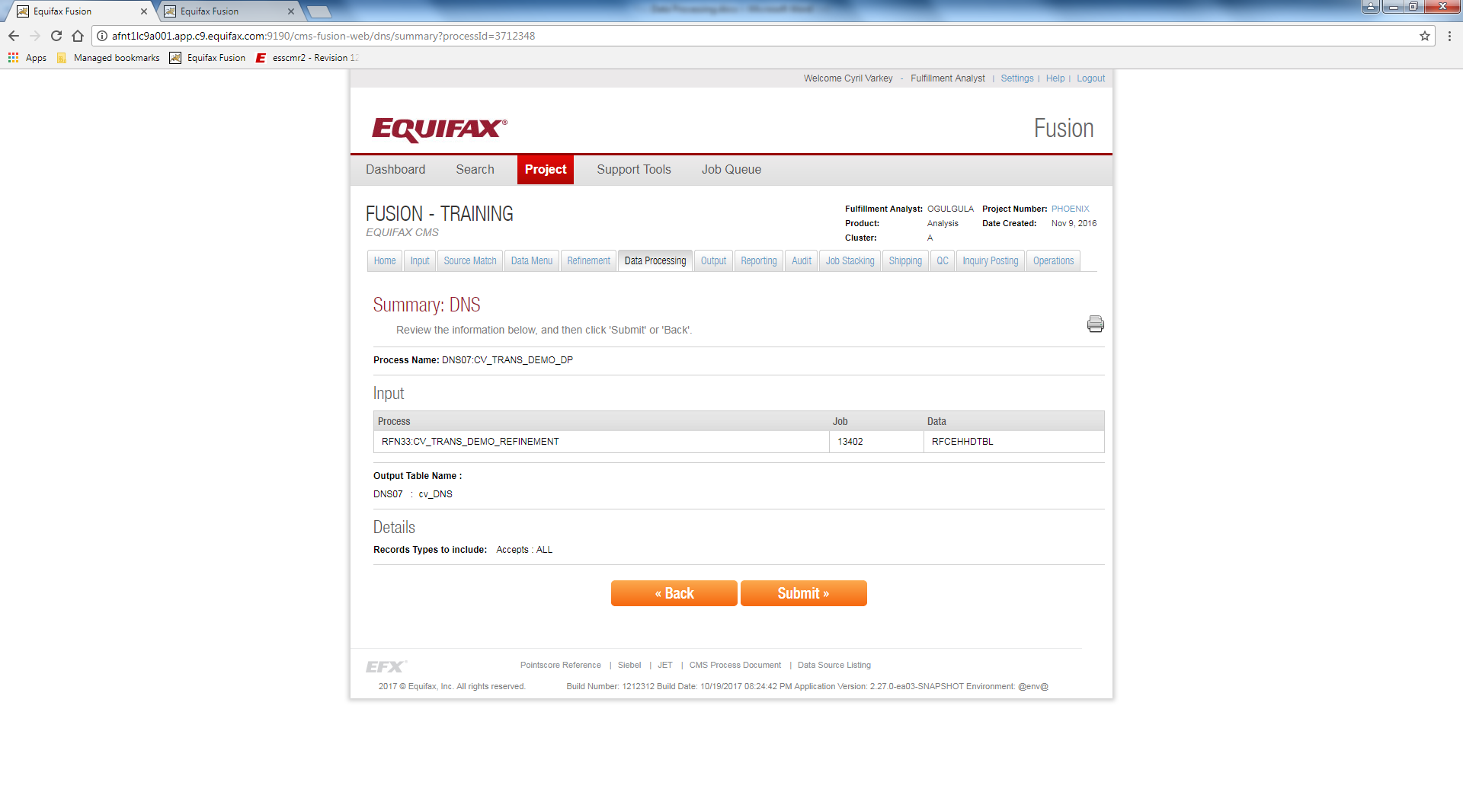

## 1.2 Random Nth

This is used for selecting the records on a random basis. This is basically done when the customer requires 100 records, where the input/processed file contains 2000+ records. The screenshots for the process is provided below:

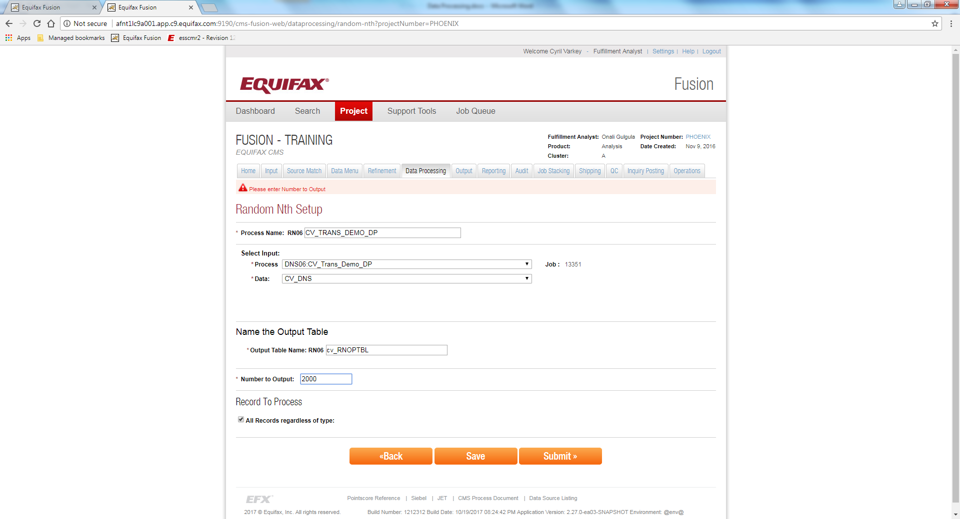

### ****1.2.1 Process Name****

This field is used to give a name for the Data Processing job. It is prefixed with an auto generated keyword called as **Process Identifier**, which is used to given the unique names process, so the user does not need to worry about the uniqueness of the names.

### ****1.2.2 Select input****

This section is used to select the particular process. This should be any process that contains PII information to match against the credit file. User can select the process. When the process is selected its Job ID will be displayed under the Job heading.

### ****1.2.3 Name and Output Table****

This section is used to give a name for the output table. Here also the process identifier is used as prefix for the output table name to avoid the naming conflicts.

### ****1.2.4 Number to Output****

This section is used to specify the number of records that you need to retrieve randomly.

### ****1.2.5 Record to Process****

This section defines the type of records to process from the selected input, such that the filtering of unwanted record is done. The filtering options available are the Accepts, Rejects and All Records as per the options mentioned in the below screenshot.

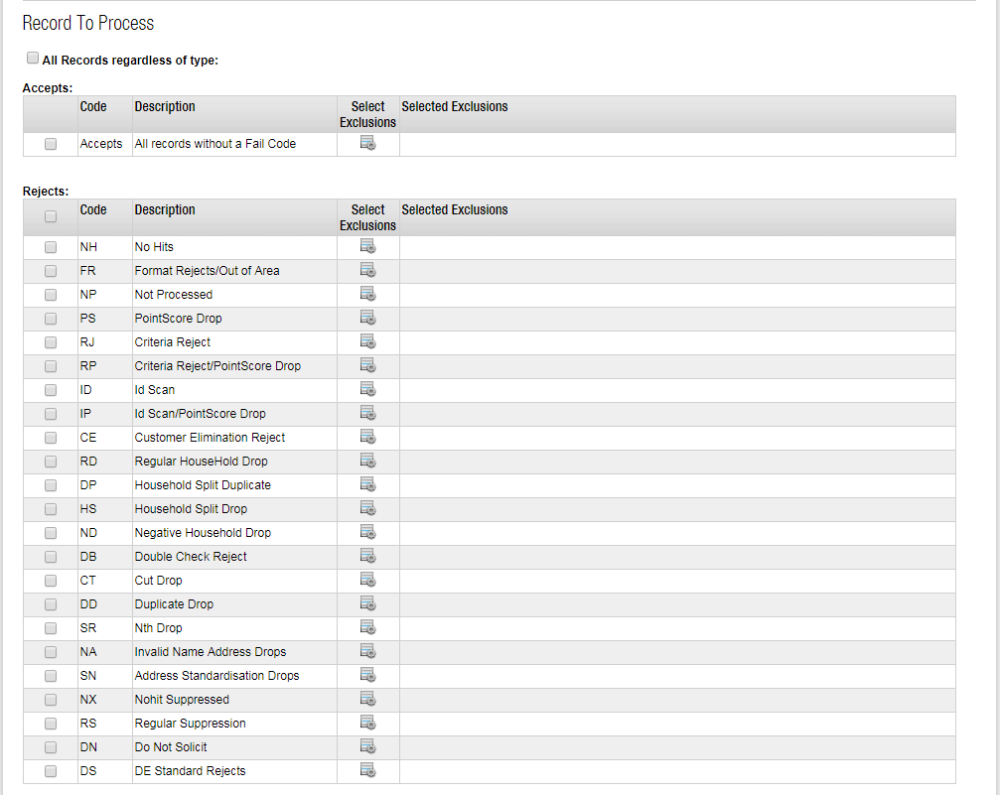

## 1.3 Full File Fixed

This is one of the ACROFILE format for providing the consumer reports to the customer, in a clear and concise format. This is a human/machine readable file format, which defines specified data in specified columns.

FFF is the format that all customers will receive the consumer data.The screen walkthrough is mentioned in the below screenshot:

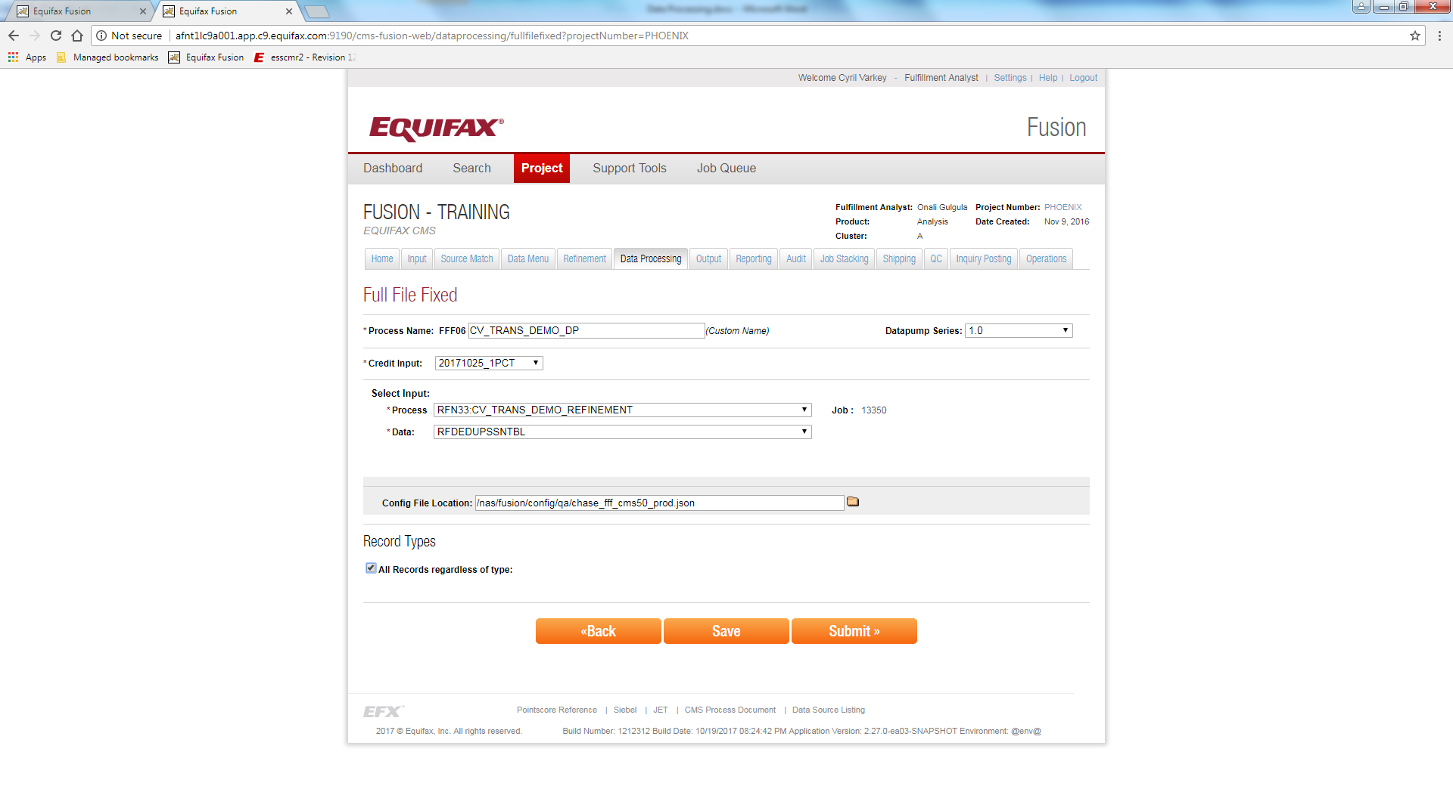

### ****1.3.1 Process Name****

This field is used to give a name for the Data Processing job. It is prefixed with an auto generated keyword called as **Process Identifier**, which is used to given the unique names for the processes, so the user does not need to worry about the uniqueness of the names.

### ****1.3.2 Datapump Series****

The datapump for processing this job is selected from this dropdown. The datapump series available currently is 1.0. Another project code named Sumerian is responsible for the development of Datapump 2.0, which is nearing completion.

### ****1.3.3 Credit Input****

This refers to the copy of ACRO data against which the data has to be verified and extracted.

### ****1.3.4 Select input****

This section is used to select the particular process. This should be any process that contains PII information to match against the credit file. User can select the process from the process drop down. When the process is selected its Job ID will be displayed under the Job heading

### ****1.3.5 Config File Location****

This defines the file template for generating the files in the ACROFILE template.

### ****1.3.6 Record Types****

This section defines the type of records to process from the selected input, such that the filtering of unwanted records is done. The filtering options available are the Accepts, Rejects and All Records as per the options mentioned in the below image.

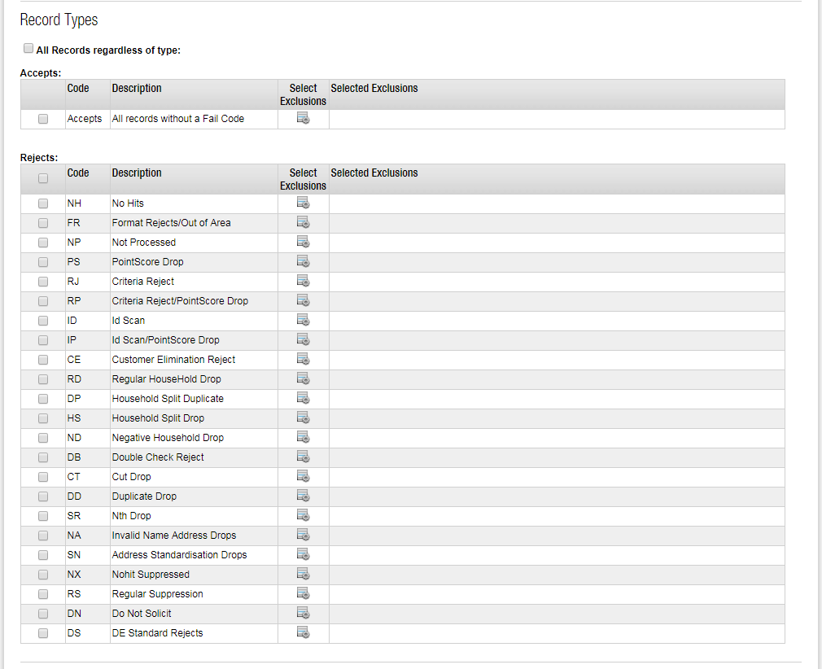

## 1.4 Filter

Using this mechanism, the data received as part of refinement is filtered out as per the customer needs. If a customer/process requires only certain fields within a certain range of values, the particular data is extracted and processed to provide output file(s).

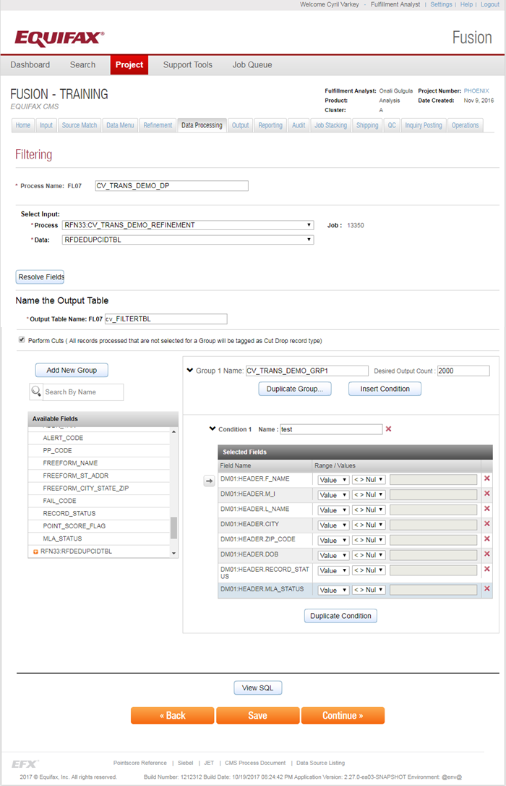

### ****1.4.1 Process Name****

This field is used to give a name for the Data Processing job. It is prefixed with an auto generated keyword called as **Process Identifier**, which is used to given the unique names process, so the user does not need to worry about the uniqueness of the names.

### ****1.4.2 Select input****

This section is used to select the particular process. This should be any process that contains PII information to match against the credit file. User can select the process. When the process is selected its Job ID will be displayed under the Job heading.

### ****1.4.3 Name and Output Table****

This section is used to give a name for the output table. Here also the process identifier is used as prefix for the output table name to avoid the naming conflicts.

### ****1.4.4 Perform Cuts****

All the records processed that are not selected for a group will be tagged as Cut Drop record type.

### ****1.4.5 Group Name and Condition****

This section refers to the grouping of data into a single custom table, where the structure and range of values for the condition is defined. Multiple conditions can exist for the group, but it is mandatory to have the same data grouping.

The Summary view of the Filter is as below

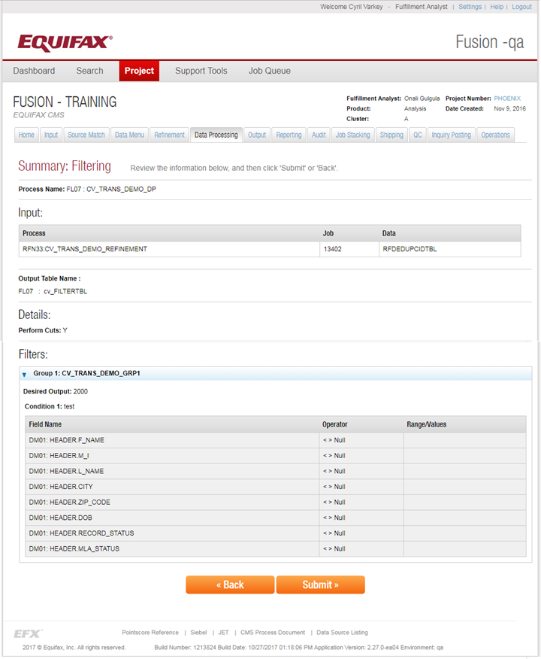

## 1.5 Match /Join

Match is based on the legacy file based processing where files are matched by using a match key. Then we used to write files having matches and another containing unmatched. We are performing a join on two files/tables Master file and the Match file. Match file can come from either the current project or an entirely different project.

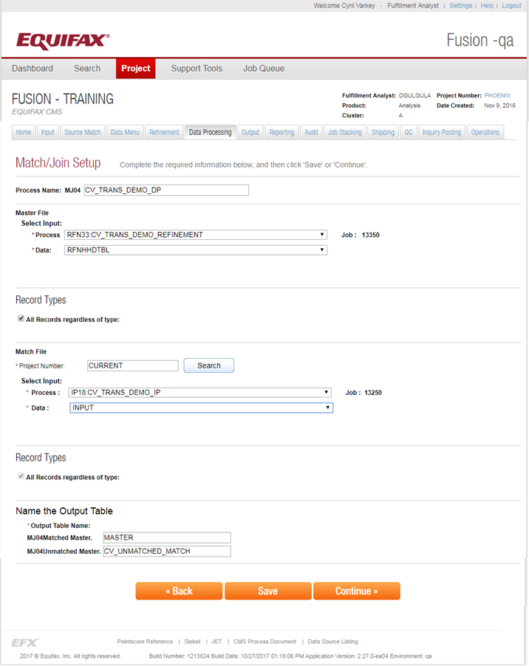

### ****1.5.1 Process Name****

This field is used to give a name for the Data Processing job. It is prefixed with an auto generated keyword called as **Process Identifier**, which is used to given the unique names process, so the user does not need to worry about the uniqueness of the names.

### ****1.5.2** Select input**

This section is used to select the particular process. This should be any process that contains PII information to match against the credit file. User can select the process. When the process is selected its Job ID will be displayed under the Job heading.

### ****1.5.3 Match File Select input****

This section is used to select the particular process for the match file. The Match file details can come from either the current project or an entirely different project (by providing the corresponding **Project Number**). This should be any process that contains PII information to match against the credit file. User can select the process from the process drop down. When the process is selected its Job ID will be displayed under the Job heading.

### ****1.5.4 Record Types****

This section defines the type of records to process from the selected input, such that the filtering of unwanted records is done. The filtering options available are the Accepts, Rejects and All Records as per the options mentioned in the below image.



### ****1.5.5 Name and Output Table****

This section is used to give a name for the output table. Separate table names are provided for the matched and unmatched tables. Here also the process identifier is used as prefix for the output table name to avoid the naming conflicts.

In the below screenshot the corresponding match keys are selected and the Continue button is clicked.

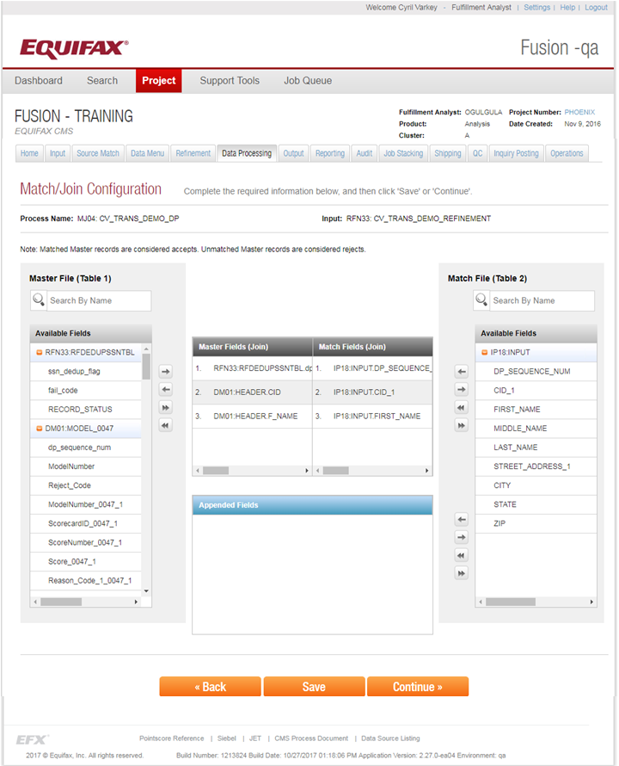

Next the Submit Button is clicked to submit the job.

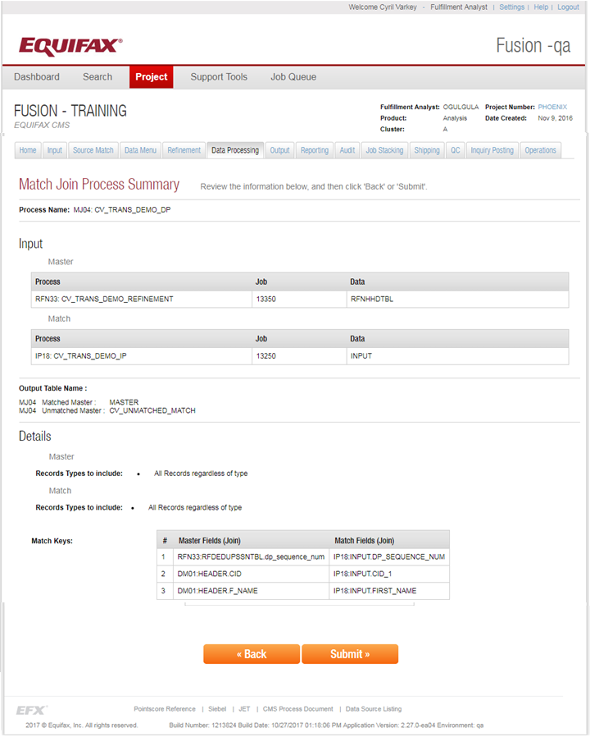

### 1.5.6 Match Join Stats

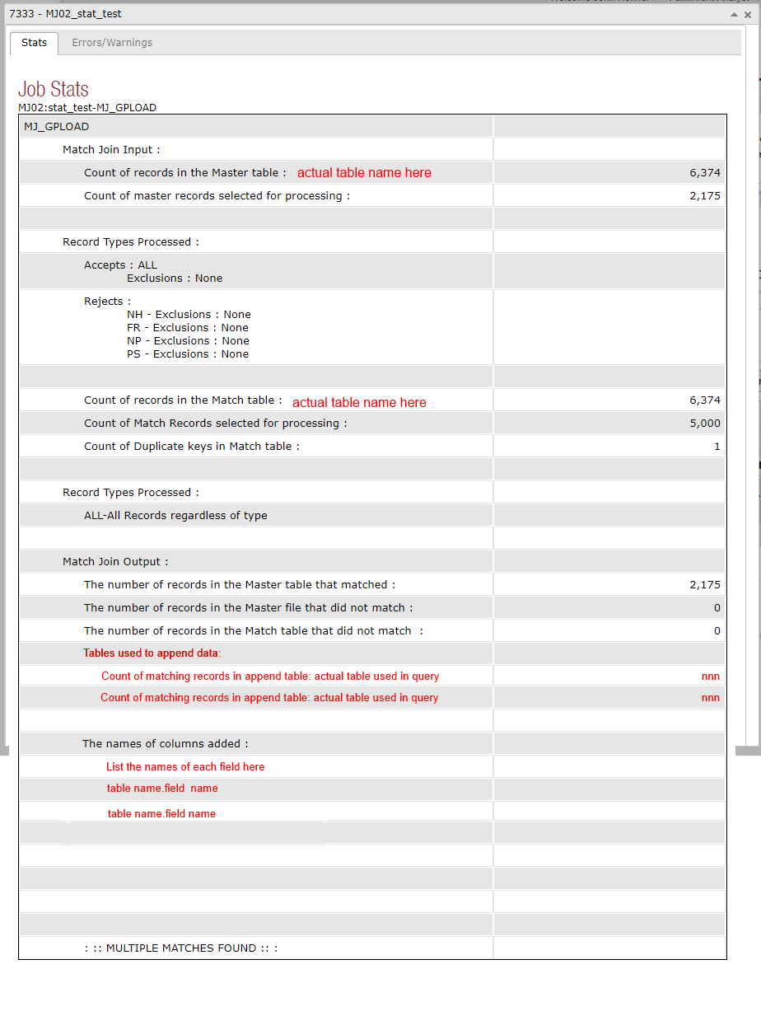

 The stats displays the actual table name of the table used for the Match and for the data appended.

## 1.6 Custom Data Setup

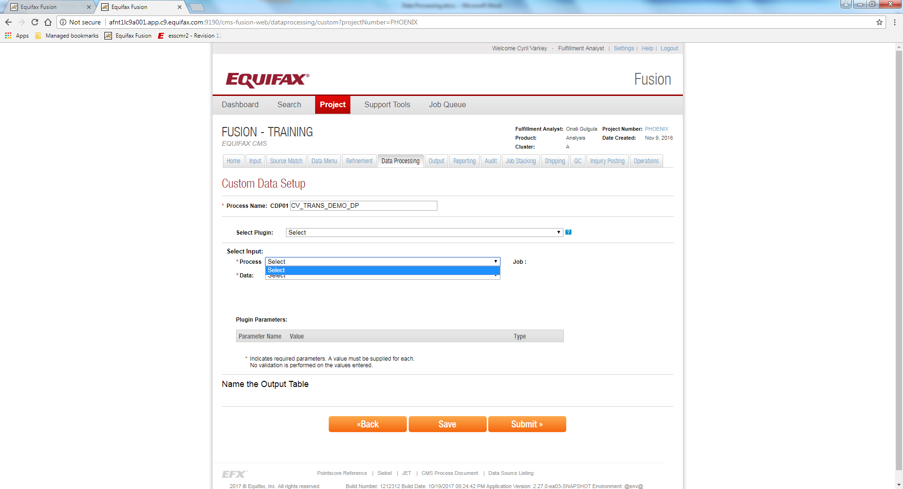

## 1.7 Rolling Suppression

A suppression list is a list of suppressed e-mail addresses used by e-mail senders to comply with CAN-SPAM Act of 2003 (United States of America). CAN-SPAM requires that senders of commercial emails provide a functioning opt-out mechanism by which email recipients can unsubscribe their email address from future email messages. The unsubscribed email addresses are placed into a "suppression list" which is used to "suppress" future email messages to that email address.

In case of *rolling suppression*, the persons who are already contacted for a product a week before, will be excluded from the next list, such that the people is given a bit more of time for evaluating the product. In case of a new suppression, this is verified against previous Projects Shipped Files.

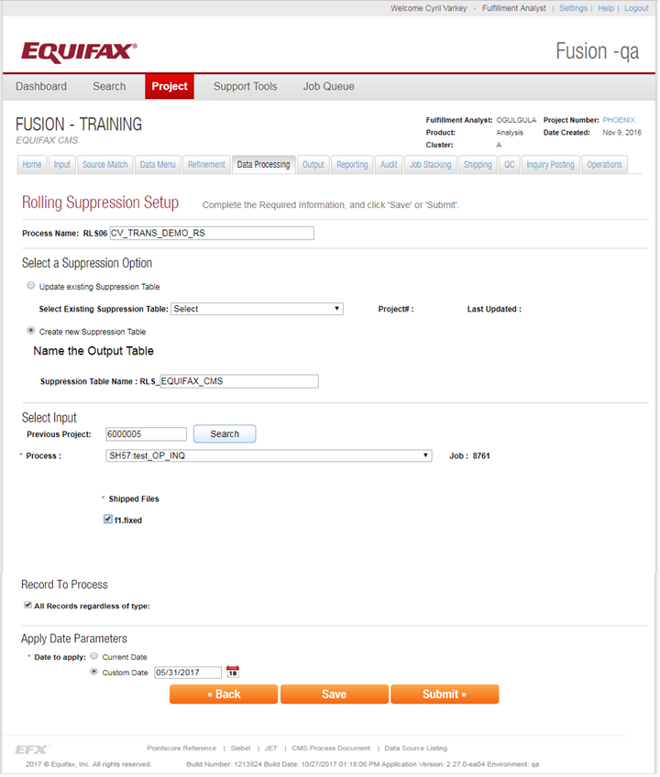

### ****1.7.1 Process Name****

This field is used to give a name for the Data Processing job. It is prefixed with an auto generated keyword called as **Process Identifier**, which is used to given the unique names for the process, so the user does not need to worry about the uniqueness of the names.

### ****1.7.2 Select a Suppression Option****

Update Existing Suppression table will updated the existing suppression table. When we need to create a new suppression when there are no suppressions associated to the current project.

### ****1.7.3 Name the Output Table****

This section is used to give a name for the output table. Here also the process identifier is used as prefix for the output table name to avoid the naming conflicts.

### ****1.7.4 Select input****

This section is used to select the particular process. User can select the process from the process drop down. When the process is selected its Job ID will be displayed under the Job heading.

### ****1.7.5 Record to Process****

This section defines the type of records to process from the selected input, such that filtering of unwanted records is done. The filtering options available are the Accepts, Rejects and All Records as per the options mentioned in the below image.



### ****1.7.6 Apply Date Parameters****

We need to select a date against which the suppression needs to be applied.

## **1.8 MLA Standalone**

The Military Lending Act (MLA) says that you can’t be charged an interest rate higher than 36% on most types of consumer loans and provides other significant rights.

The MLA applies to active-duty service members (including those on active Guard or active Reserve duty) and covered dependents.

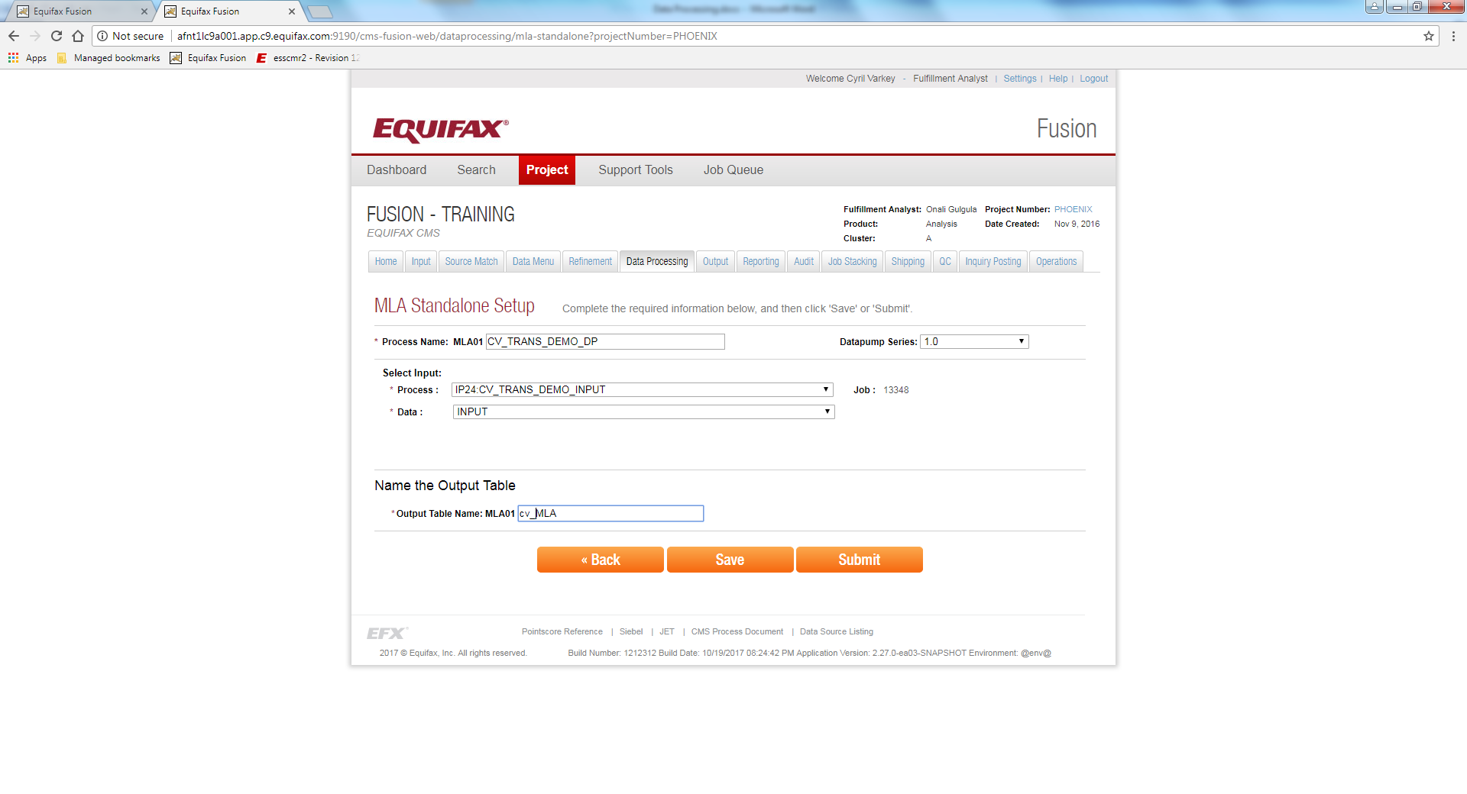

Your rights under the MLA include:

* A 36% interest cap.  You can’t be charged more than a 36% Military Annual Percentage Rate (MAPR), which includes the following costs in calculating your interest rate (with some exceptions):
* Finance charges,
* Credit insurance premiums or fees,
* Add-on products sold in connection with the credit, and
* Other fees like application or participation fees, with some exceptions.
* No mandatory waivers of consumer protection laws.   A creditor can’t require you to submit to mandatory arbitration or give up certain rights you have under State or Federal laws like the Service members Civil Relief Act.
* No mandatory allotments. A creditor can’t require you to create a voluntary military allotment in order to get the loan. An allotment is an automatic amount of money taken from your paycheck to pay back your loan.
* No prepayment penalty. A creditor can’t charge a penalty if you pay back part – or all – of the loan early.

### ****1.8.1 Process Name****

This field is used to give a name for the Data Processing job. It is prefixed with an auto generated keyword called as **Process Identifier**, which is used to given the unique names for the source match processes, so the user does not need to worry about the uniqueness of the names.

### ****1.8.2 DataPump Series****

The datapump for processing this job is selected from this dropdown. The datapump series available currently is 1.0. Another project code named Sumerian is responsible for the development of Datapump 2.0, which is nearing completion.

### ****1.8.3 Select input****

This section is used to select the particular process. User can select the process from the process drop down. When the process is selected its Job ID will be displayed under the Job heading.

### ****1.8.4 Output Table****

This section is used to give a name for the output table. Here also the process identifier is used as prefix for the output table name to avoid the naming conflicts.